Email #1 – CGMA – Helping Our Own
The Coast Guard workforce does incredible things every day. And Coast Guard Mutual Assistance (CGMA) is with you every step of the way. For 100 years, Coast Guard Mutual Assistance has been helping Coast Guard men and women and their families.
Who?
Coast Guard Mutual Assistance (CGMA) exists to help you, your family, your shipmates, and co-workers in times of need. CGMA is an independent non-profit charitable organization dedicated to providing financial assistance to the Coast Guard community.
What?
Mutual Assistance serves as a vital financial safety net to the Coast Guard community for individual situations and during widespread disasters. Each program is designed to ensure that short term financial challenges don’t become long term problems. Last year CGMA provided $9.9 million to 6,825 Coast Guard members in 2023 thanks to donors from the Coast Guard community.
Where?
CGMA has a strong presence to serve the whole Coast Guard community with more than 591 CGMA Representatives at 132 shore units and 54 cutters in 35 states and territories across 19 time zones. Established and operated by Coast Guard people for Coast Guard people, CGMA provides a way to extend compassion to one another in times of need.
How?
Getting assistance to Coast Guard people in need takes partnership and teamwork from all of us. CGMA connects the Coast Guard community providing a way to Help Our Own through the tough times.
In his campaign message, MCPOCG Jones explained, “CGMA extends a helping hand in times of need. Mutual Assistance is one of the farthest- reaching resources within our community, and that’s why Carol and I support CGMA with a monthly allotment donation.”
Each week of the campaign will highlight different ways that CGMA shows up and supports the Coast Guard community. Stay tuned so you are ready utilize and recommend this resource at the right time. Your tax-deductible donation during the campaign ignites CGMA’s ability to respond quickly. This year, in recognition of 100 years of extraordinary support of the Coast Guard community, we’re challenging everyone to give back. 100 for 100! Our goal this year is 100% unit participation. Starting an allotment of just $1.00 a month has the power to make a lasting impact in the life of a struggling shipmate.
As Commandant Fagan emphasized in her campaign message, “CGMA can only be there for our shipmates and their families when we give. It is up to each of us to keep CGMA strong, ready to meet the needs of our shipmates and coworkers. Thank you for generously supporting Coast Guard Mutual Assistance!”
For more info now, visit the newly updated CGMA website, www.mycgma.org.
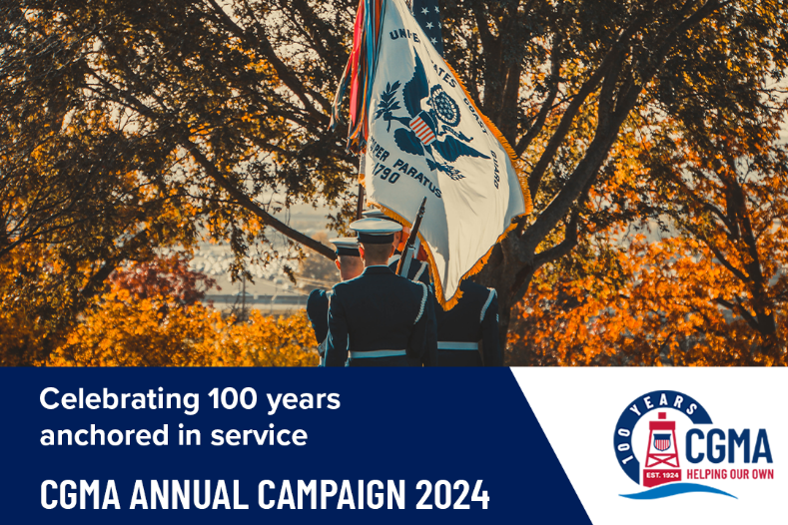
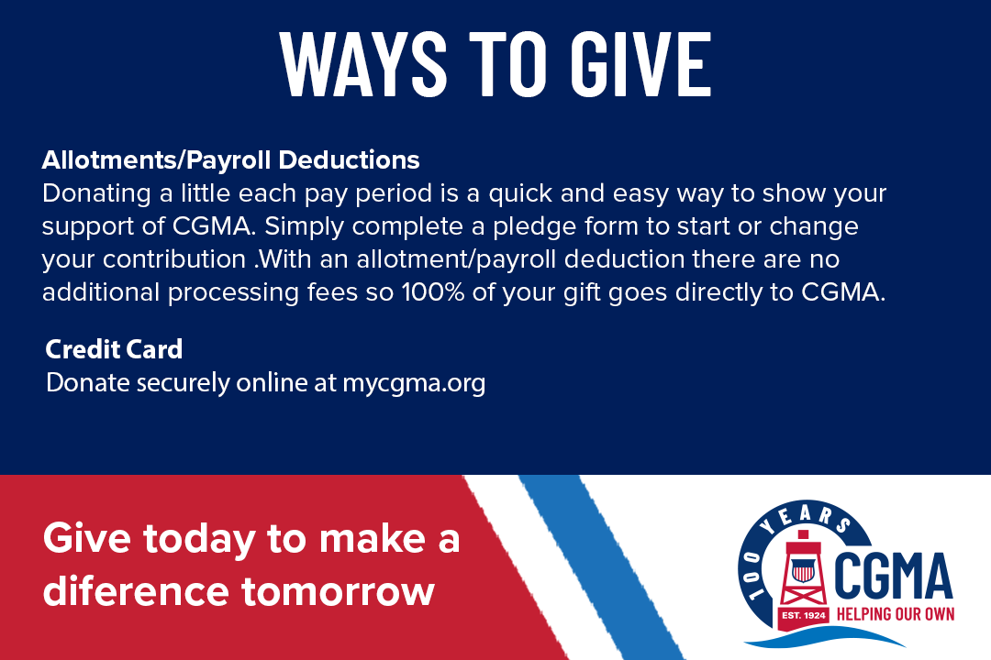I

