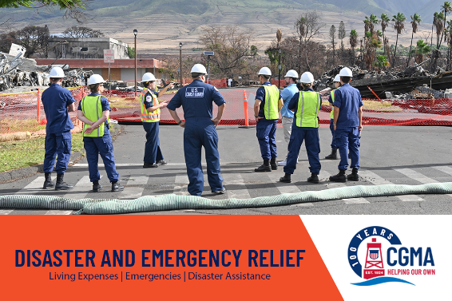

(Week 3) CGMA Campaign Email – Disaster and Emergency Relief

In response to widespread regional natural disaster like hurricanes or wildfires, CGMA Disaster Assistance provides funds for food spoilage due to loss of power, insurance deductibles, clean-up from broken water pipes, and increased utility costs. Your donation will accelerate this response. With the help from our donors, CGMA is ready to serve the Coast Guard community every day.

Last year over $777 thousand of support was given to affected more than 555 members in response to Typhoon Mawar, Hawaii Wildfires, and other storms. While the Coast Guard made adjustments to continue to perform critical missions that protect our national interests, ensure public safety, and promote economic prosperity, CGMA worked to help us.

CGMA’s skilled and practiced emergency response is at the core of our mission. For a hundred years, CGMA has proved a ready and reliable source of support for Coast Guardsmen and their families in disaster and emergencies. Through fires and floods, hurricanes, and medical emergencies, CGMA helps. Every time.

Trying times like these are exactly why CGMA exists. We know that during seasons when our shipmates may be struggling there is a source of support. When regions face storms or an individual suffers a tragedy, CGMA is here to help!

For more information on our Disaster Assistance or any of CGMA’s other programs, talk to your local CGMA Rep or visit the CGMA website: www.mycgma.org.

You can give a one time gift at any time during the year. During the campaign, a credit card donation may be made and still count towards your unit’s campaign totals, simply include your OPFAC number and unit name.

