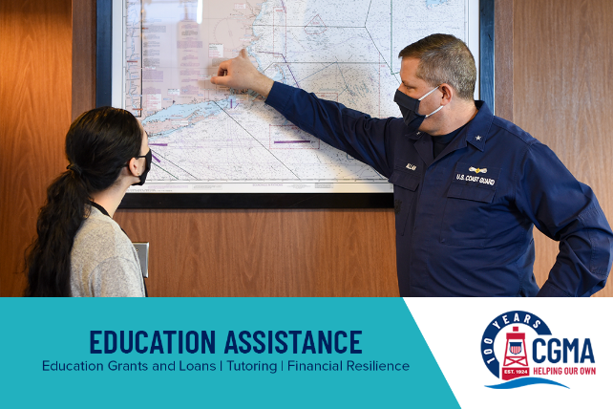
Week 4: CGMA – Support for Education
Education matters, and CGMA is ready to help you, your spouse and college-aged kids go to school, study, and succeed! Through education grants and zero-interest loans, CGMA fosters long-term financial well-being by helping Coast Guard families pursue their academic goals.
Check out CGMA Education Programs:

- Supplemental Education Grant (SEG) – Provides up to $750 grant per calendar year to off-set the costs of fees, books, study guides, supplies, equipment, and even computers as well as other educational costs required by the course of study. This is a very popular program.
- Education Zero-Interest Loan – The CGMA Education Loan Program offers financial assistance by providing CGMA clients an interest-free loan of up to $3,000 for each student to assist with college education expenses, including tuition.
- Loan Origination Fee Reimbursement - Stafford/PLUS Loan Reimbursement offers help to clients and their families who finance post-secondary education through the Federal Stafford Loan or Federal Parent Loan for Undergraduate Students (PLUS), by refunding the mandatory loan fee (1-4%) that is charged each borrower.
- Cool Loan - an interest-free loan up to $4,500 for CG COOL credentialing, covering essentials like training and exam fees.
In recent years CGMA launched two programs to help families with education costs linked to PCS moves.
- Spouse Professional Requirements Loan - is designed to help with the cost of spouse being licensed or certified in a new state or municipality. Loans can be authorized up to $5,000 for this purpose, interest-free.
- Education Advocate Grant - Up to $500 grant for the cost of an advocate’s assistance in initiating or completing a new Individualized Education Plan (IEP) or an Individual Family Support Plan (IFSP).
Talk to your Local Representative for more information or to apply for CGMA Education Programs visit: https://mycgma.org/programs/?cat_id=16
Post-secondary students in the family are supported by CGMA. Education matters, and we’re ready to help you, your spouse and college kids go to school, study, and succeed!

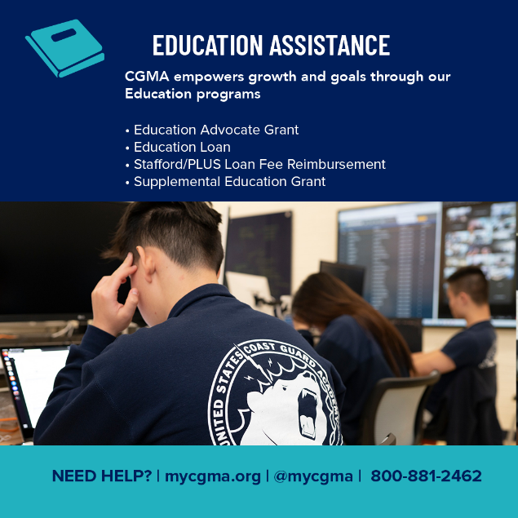
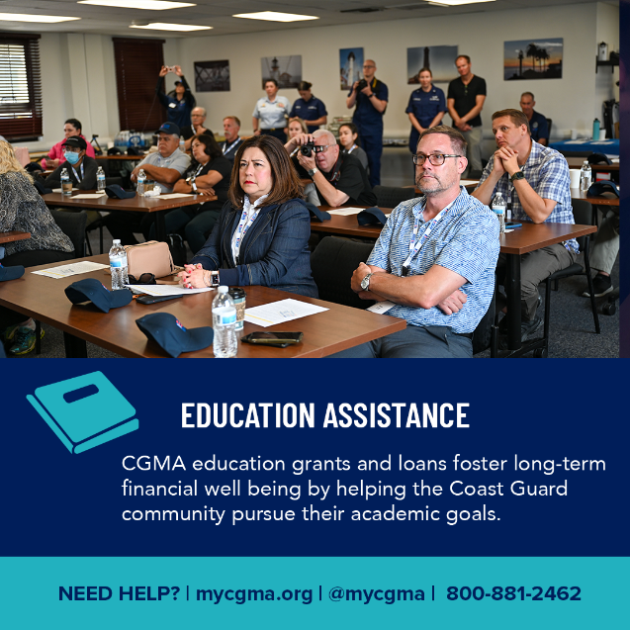
The most powerful way to give is through allotment or payroll deduction. By donating a little each pay period, you equip CGMA with a reliable and steady source of funds to support shipmates when and where they need help. Even a small increase to your current deduction can make a big difference. You can start or bump up your Active Duty allotment or Civilian payroll deduction online. Remember to include your OPFAC and Unit Name so your local unit gets credit for the campaign!

