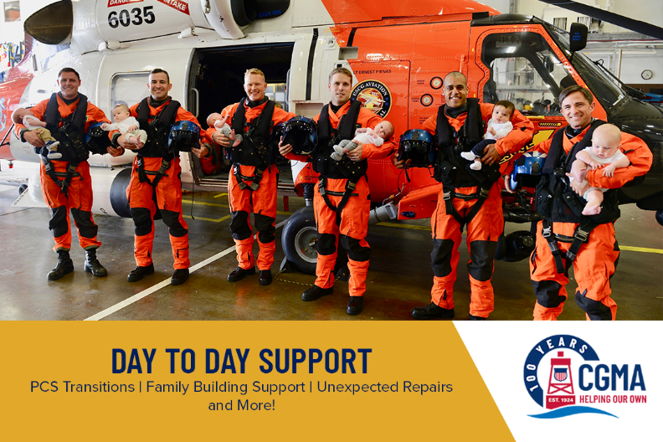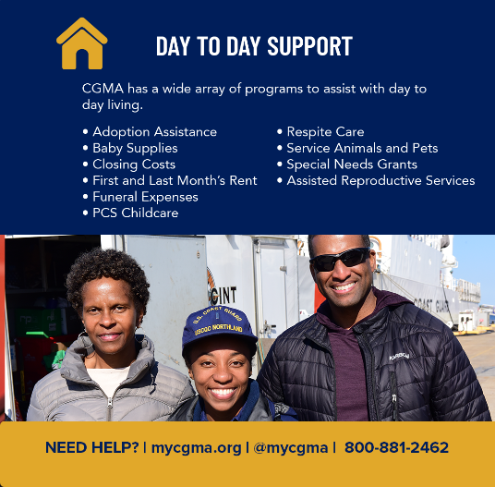
Email #1 – CGMA – Not just for emergencies
CGMA is an amazing resource not only in times of emergency but for day-to-day financial needs as well. CGMA offers a wide range of support programs to help with
- Welcoming a new baby baby supplies - layette package (includes a receiving blanket, clothes and other very cute items for a newborn baby) to families of the Coast Guard community following the birth or adoption of a child.
- Support for special needs - including grants for costs of activities such as camps or clubs, adaptive equipment, and other resources designed to meet special needs including respite care.
- Adoption Grants and Loans - financial assistance for those looking to build their families through adoption
- Assisted Reproductive Services Loan - this interest-free loan is available for clients wishing to engage in a recognized fertility treatment program or associated costs not covered by TRICARE.
- Support for survivors of domestic violence through the Safe Harbor program.
- Funeral Expenses
Unexpected vet bills
In recent years, CGMA expanded the Special Needs Grant Program to up to $3,000 every 5 years to Active Duty CGMA clients who are faced with increased financial demands related to the care and support of their dependents with special needs.
For more information on these programs and other resources available for you and your family, please visit www.mycgma.org or find CGMA on Twitter//Instagram: @MyCGMA
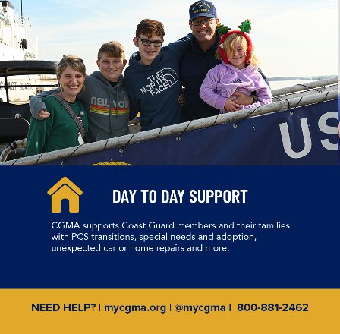
Email #2 – CGMA – PCS Support
With PCS Season around the corner, we want everyone to be aware of four specific resources CGMA offers to support upcoming moves.
1 - OCONUS Rental Car Assistance (ORCA)
ORCA is newer program available to all military and civilian personnel transferring OCONUS this year. It will ensure that resources are available for a rapid and easy arrival at the new duty location.
2 – PCS Child Care
The PCS Child Care Program provides up to $450 for a family to help cover the cost of child care during PCS related activities. CGMA will pay for babysitting or commercial child care while your household goods are being picked up….or dropped off. The PCS Child Care Reimbursement is open to Regular Coast Guard Active Duty and ADOS Reserve members in pay grades E6 and below, O-2 and O-1.
3—Housing & PCS Incidentals Assistance
CGMA’s Housing Assistance Loan Program can help with settlement charges when purchasing, selling, or refinancing a home, or for deposits when renting (first/last month’s rent and security deposit). Assistance may also be provided for the cost of establishing utilities.
CGMA also offers a PCS Incidentals Loan which is intended to help Coast Guard military personnel with unexpected costs that accompany a PCS move. These may include the cost of house hunting prior to the move, hotel stays beyond the allotted 10 days when household goods are delayed, boarding pets temporarily while movers are present or when the client is staying at hotels where pets are not allowed, and purchasing household necessities such as food, cleaning supplies, window treatments, toiletries new garbage cans, mats, area rugs, etc., that are needed for settling into the new residence.
4—Breast Milk Transport - CGMA will provide financial assistance to members or spouses who are faced with out of pocket costs for the shipment or transport of breast milk for a host of reasons including a PCS move.
For more information on these programs, talk to your local CGMA Representative or visit the CGMA website, www.mycgma.org.

