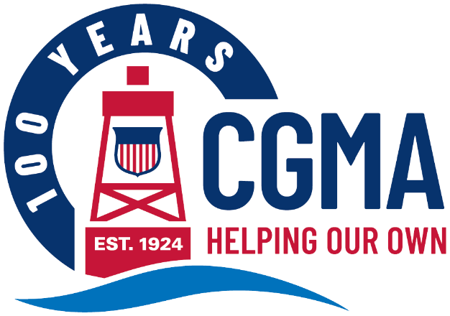
CGMA 2025 Annual Fundraising Campaign Social Media Kit
The following are messages you can use to promote the CGMA Annual Fundraising Campaign to your units. The components are designed to be used in multiple ways to make it easy for you to get your message out in whatever way will reach your audience best.
Each message includes:
Banner Image This can be used as an email banner or a newsletter header
Message Copy This includes a headline and ‘story.’ Use it as-is for a newsletter story or intranet post or use the headline as the subject and the copy as the body of an email.
Graphic This can be used on any internal social media channels you may use, or to accompany a newsletter, intranet post or email message
The messages are organized by “Week Of” date, so you know exactly when to share each one throughout the campaign.
Below is the copy for each week’s message. You will find the corresponding banner images and graphics in that week’s folder.

Week of April 1
CGMA Annual Fundraising Campaign Now Underway
The annual fundraising campaign for Coast Guard Mutual Assistance (CGMA) has just kicked off. This is your chance to donate to the US Coast Guard’s official aid society.
In everything we do, CGMA embodies The Power of Us. Funded 100% through donations, our largest donor pool by far is you – the Coast Guard community. You are also our only clients. Your support makes it possible for us to help fellow Coasties in need year after year.
Please consider donating today, through a one-time donation or a payroll allotment, and help us continue providing the support you deserve.

