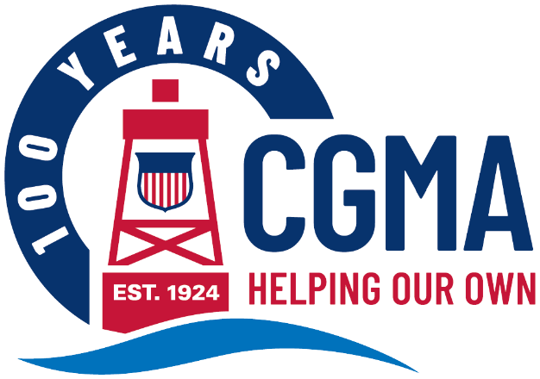
CGMA 2025 Annual Fundraising Campaign Social Media Kit
The following are messages you can use to promote the CGMA Annual Fundraising Campaign to your units. The components are designed to be used in multiple ways to make it easy for you to get your message out in whatever way will reach your audience best.
Each message includes:
Banner Image This can be used as an email banner or a newsletter header
Message Copy This includes a headline and ‘story.’ Use it as-is for a newsletter story or intranet post or use the headline as the subject and the copy as the body of an email.
Graphic This can be used on any internal social media channels you may use, or to accompany a newsletter, intranet post or email message
The messages are organized by “Week Of” date, so you know exactly when to share each one throughout the campaign.
Below is the copy for each week’s message. You will find the corresponding banner images and graphics in that week’s folder.

Week of April 14
Help CGMA Continue its Mission for Years to Come
For 100 years, Coast Guard Mutual Assistance has been helping Coast Guardsmen. From caring for Coast Guard widows and members returning from the First World War to serving those impacted by the 2019 Government Shutdown, the COVID-19 pandemic, and more recent events like Hurricane Helene and the California wildfires — CGMA has proved a sure and steady resource.
The Power of Us is about making sure that no one in our Coast Guard community has to navigate financial challenges alone. Our grants and zero percent loans help ensure short-term financial challenges don’t become long-term financial problems.
Get Help by learning more about our programs at mycgma.org.
Give Help by making sure these programs are available to your fellow Coasties for years to come. Make a one-time donation or setting up (or increasing) a payroll allotment today.

