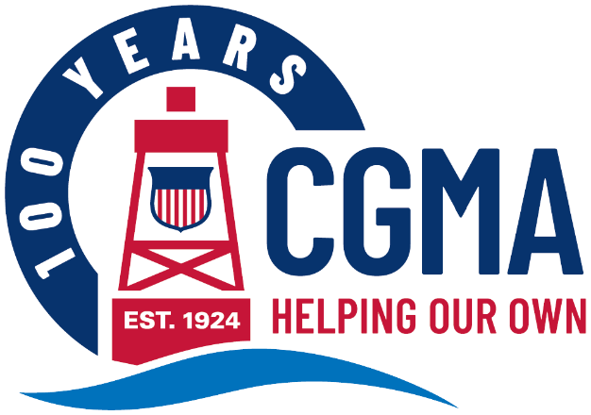
CGMA 2025 Annual Fundraising Campaign Social Media Kit
The following are messages you can use to promote the CGMA Annual Fundraising Campaign to your units. The components are designed to be used in multiple ways to make it easy for you to get your message out in whatever way will reach your audience best.
Each message includes:
Banner Image This can be used as an email banner or a newsletter header
Message Copy This includes a headline and ‘story.’ Use it as-is for a newsletter story or intranet post or use the headline as the subject and the copy as the body of an email.
Graphic This can be used on any internal social media channels you may use, or to accompany a newsletter, intranet post or email message
The messages are organized by “Week Of” date, so you know exactly when to share each one throughout the campaign.
Below is the copy for each week’s message. You will find the corresponding banner images and graphics in that week’s folder.

Week of May 12
Donations are Down, Requests are Up. Your Donations are Critical to Helping Coasties in Need
In the more than 100 years since CGMA was founded, the Coast Guard community has been the lifeblood of CGMA – the primary source of our funding. While the needs of the community are increasing, though, funding is shrinking.
Allotments were once the backbone of sustained giving. They are automatic, recurring and are deducted directly from your paycheck. Unfortunately, they are dropping rapidly. Over the last few decades, allotments among Active Duty Coast Guard members have steadily declined at a pace of 877 allotments each year. This translates to a loss of about $49,000 per year. Over the last decade, the cumulative impact of this has been a nearly 50% reduction in allotments.
If you are not in a position to make a payroll deduction, you also have the ability to make a one-time or recurring donation. Even small payroll contributions, when pooled together, make a powerful impact.
Please consider signing up for payroll allotment, one-time or recurring donation, so we can continue to support Coast Guard community members at the most important times of their lives. You can ensure that resources remain available for those who need them most.

