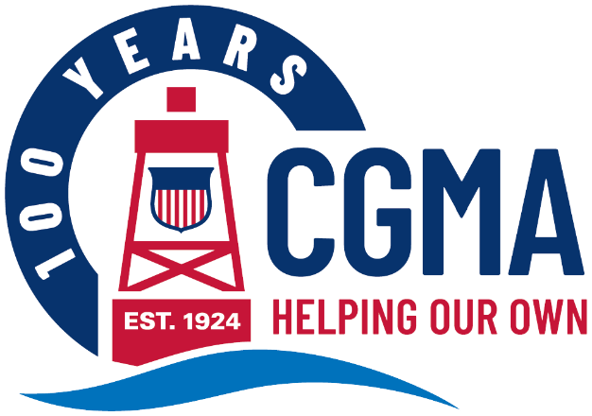
CGMA 2025 Annual Fundraising Campaign Social Media Kit
The following are messages you can use to promote the CGMA Annual Fundraising Campaign to your units. The components are designed to be used in multiple ways to make it easy for you to get your message out in whatever way will reach your audience best.
Each message includes:
Banner Image This can be used as an email banner or a newsletter header
Message Copy This includes a headline and ‘story.’ Use it as-is for a newsletter story or intranet post or use the headline as the subject and the copy as the body of an email.
Graphic This can be used on any internal social media channels you may use, or to accompany a newsletter, intranet post or email message
The messages are organized by “Week Of” date, so you know exactly when to share each one throughout the campaign.
Below is the copy for each week’s message. You will find the corresponding banner images and graphics in that week’s folder.

Week of May 26
Time is Running Out to Donate to the CGMA Annual Fundraising Campaign
The CGMA Annual Fundraising Campaign is wrapping up on May 31 and we want to take a moment to thank everyone who has donated. If you haven’t had a chance yet, please consider donating this week.
From Day-to-Day Support to Education Assistance to Emergency and Disaster Relief, we provide Coast Guard community members the help they need when they need it thanks to the generosity of all its members. While we are the Coast Guard’s only official aid organization, CGMA does NOT receive any government funding. CGMA is 100% funded through donations, primarily from the Coast Guard community.
This is why it’s so important to consider donating, whether through a one-time or recurring donation or a payroll allotment – you are the reason we provided more than $8 million in critical support to our Coast Guard family.
That’s the Power of Us.

