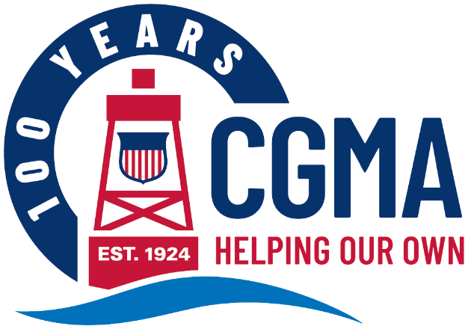
CGMA 2026 Annual Fundraising Campaign Digital Campaign Media Kit
The following are messages you can use to promote the CGMA Annual Fundraising Campaign to your units. The components are designed to be used in multiple ways to make it easy for you to get your message out in whatever way will reach your audience best.
Each message includes:
Banner Image This can be used as an email banner or a newsletter header.
Message Copy This includes a headline and ‘story.’ Use it as-is for a newsletter story or intranet post or use the headline as the subject and the copy as the body of an email. Coordinators should consider including an all hands date and time to highlight the impact of CGMA in their initial kick off email.
Graphic This can be used on any internal social media channels you may use, or to accompany a newsletter or intranet post.
The messages are organized by “Week Of” date, so you know exactly when to share each one throughout the campaign.
Below is the copy for each week’s message. You will find the corresponding banner images and graphics in that week’s folder.

Week of August 3
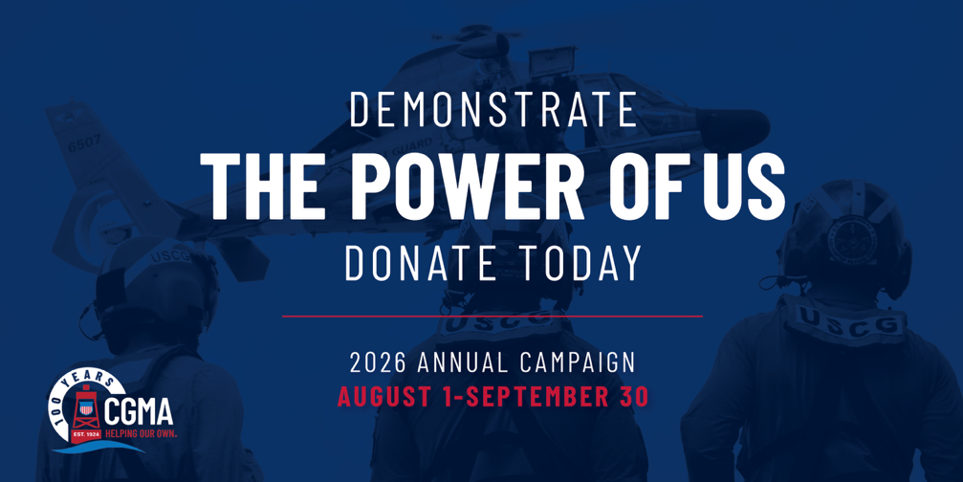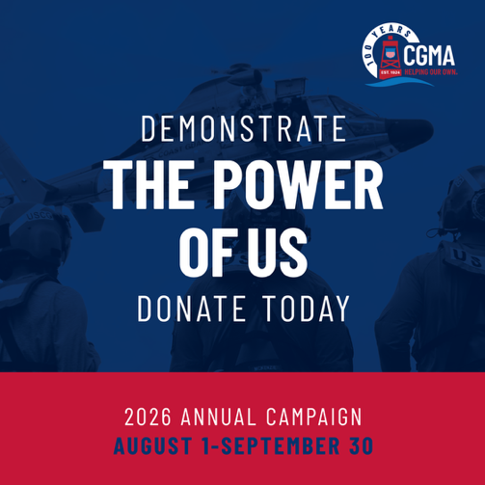

2026 CGMA Annual Campaign Now Underway
The Coast Guard Mutual Assistance (CGMA) Annual Fundraising Campaign is now underway. This is your chance to donate to our own aid society and demonstrate The Power of Us. CGMA is the U.S. Coast Guard’s official military aid society.
CG Mutual Assistance is “For Coasties. By Coasties” and 100% funded by donations. And our largest circle of support by far is you – the Coast Guard community. Your financial investment makes it possible for CGMA to help fellow Coasties in need year after year.
The Annual Campaign generates a vital stream of support to the Coast Guard Community. In 2025 alone, CGMA helped more than 4,000 members of the Coast Guard Community with $12 million in financial support – $3 million of that in grants.
Please consider donating to CGMA today, through a payroll allotment (the best way!) or one-time donation, so Coast Guard men and women can continue receiving vital financial assistance.

Week of August 17
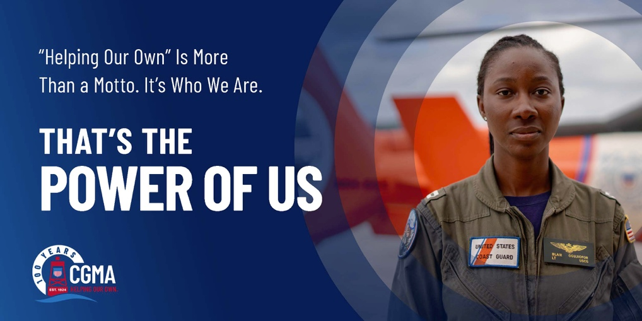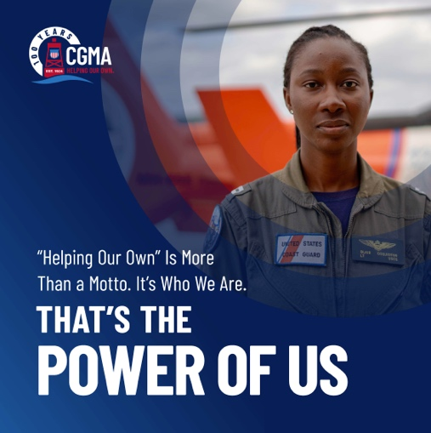

Help CGMA Continue its Mission of “Helping Our Own”
For over a century, Coast Guard Mutual Assistance (CGMA) has supported the U.S. Coast Guard. From caring for widows to serving those impacted by the COVID-19 pandemic and more recent events including Hurricane Helene and 2025 & 2026 government shutdown — CGMA has proved a sure and steady resource, providing a total of more than $260 million in direct support to members in need.
The Power of Us is about making sure no one in our Coast Guard community navigates financial challenges alone. CGMA grants and interest-free loans help ensure short-term financial challenges don’t become long-term financial problems. From PCS support to vehicle repair and education programs, together, together, it’s our mission of Helping Our Own®
- Get Help by learning more about our programs at mycgma.org.
- Give Help by starting (or increasing) your payroll allotment today or by making a one-time donation.

Week of August 31

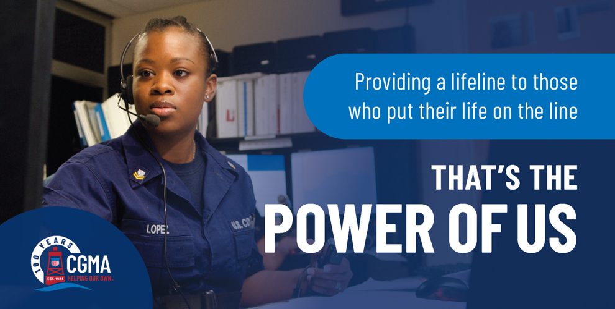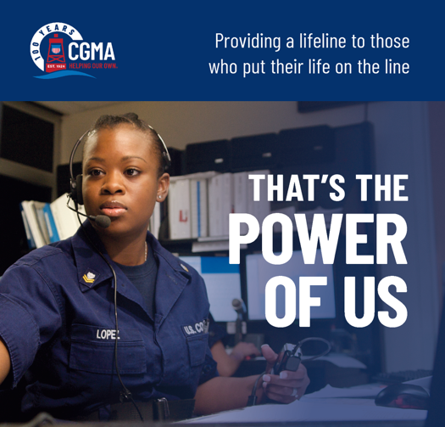
CGMA Delivered $1.5 Million in Loan Relief in 2025
More than 700 Coast Guard members received an unexpected year-end boost in 2025 when their outstanding CGMA loans were converted into grants, wiping out their remaining balances entirely. Thanks in part to a quieter-than-usual hurricane season, CGMA was able to redirect funds from other areas to support Coast Guard members still repaying CGMA loans.
In total, CGMA converted nearly $1.5 million in outstanding loans into grants across seven programs. With this effort, CGMA’s total grant funding in 2025 rose to $3 million. For ever dollar given to CGMA last year a dollar was given in grants. Direct support where it was needed most.
That’s The Power of Us.
Donate to CGMA today so financial support like this can continue. Please give through a payroll allotment (the best way!) or one-time donation.
As the U.S. Coast Guard’s official aid society, CGMA is 100% funded through donations.

Week of September 7
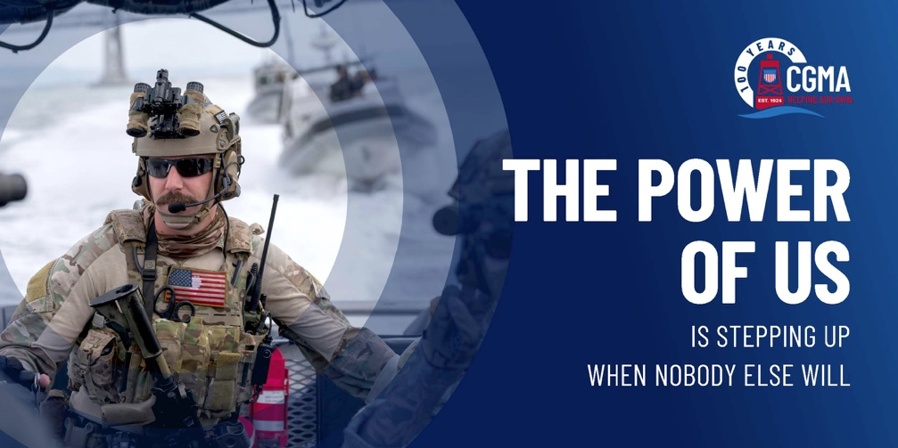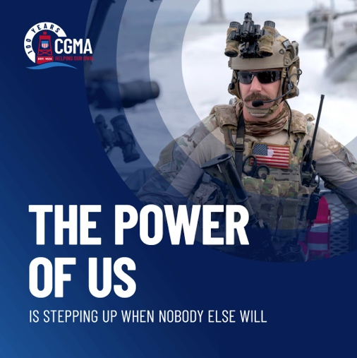

CGMA Steps Up When Nobody Else Will
When the nation entered the longest partial federal government shutdown in U.S. history on Feb. 14, 2026 — thousands of Americans struggled to keep up with basic expenses. Among the most deeply affected in our Coast Guard community were our 8,700 civilian employees.
While Active Duty members continued receiving pay, our civilian workforce members were either furloughed or required to work without pay for more than six weeks.
That’s when Coast Guard Mutual Assistance (CGMA) took action.
CGMA provided $1.7 million in interest free loans to Coast Guard civilian employees, becoming the only military aid society to offer direct financial support to civilian workers throughout the shutdown. This critical assistance allowed families to cover everyday essentials when their paychecks stopped.
That’s The Power of Us.
Donate to CGMA today so financial support like this can continue. Please give through a payroll allotment (the best way!) or one-time donation.

Week of September 21
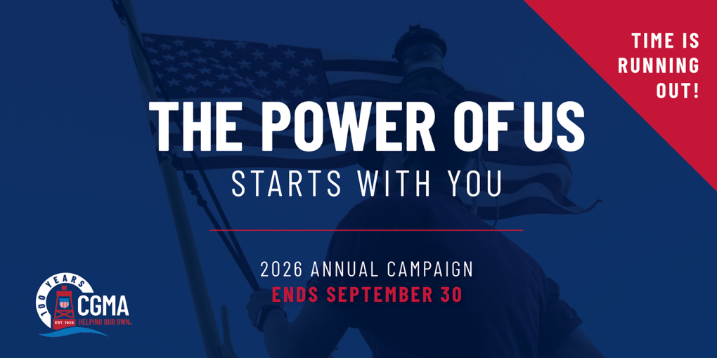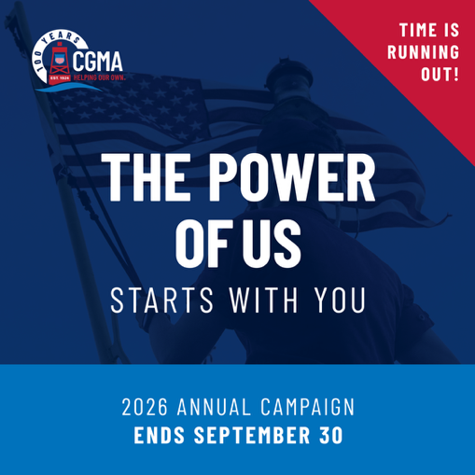
Time Is Running Out: Start or Increase Your Allotment Today
The Coast Guard Mutual Assistance (CGMA) Annual Fundraising Campaign ends on September 30. If you haven’t had a chance yet, please consider donating this week.
CGMA is 100% funded through donations, primarily from the Coast Guard community. And the best way to give is through payroll allotments. They are automatic, recurring and deducted directly from your paycheck with no processing fees.
Please consider donating today — whether through a one-time or recurring donation or a payroll allotment. Even small contributions, when pooled together, make a powerful impact. You are the reason CGMA was able to provide more than $12 million in critical support to our Coast Guard family in 2025.
That’s the Power of Us.

